Project Design Phase-II
Technology Stack (Architecture & Stack)

Date | 31 January 2025
Team ID | NM2025TMID00377
Project Name | Calculating Family Expenses using ServiceNow
Maximum Marks | 4 Marks

Technical Architecture
The technical architecture of the Family Expense Calculation System developed using ServiceNow illustrates how various system components interact to manage, process, and visualize expense data. The architecture is divided into three main layers — User Interface Layer, Application Logic Layer, and Data Storage Layer — ensuring smooth data flow and efficient performance.

- User Interface Layer:
Family members and admins interact with the system through the ServiceNow interface, where they can enter expenses, view dashboards, and manage budgets.
- Application Logic Layer:
This layer handles the main business logic. It automates expense calculations, updates totals dynamically, triggers budget alerts, and manages report generation based on the user stories (USN-1 to USN-5).
- Data Storage Layer:
All expense records, user details, and categorized data are stored securely in the ServiceNow database. The system ensures data integrity and consistency during processing.

Example: Family expense tracking and budget management system

Guidelines:
Include all the processes (As an application logic / Technology Block)
Provide infrastructural demarcation (Local / Cloud) Indicate external interfaces (third party API’s etc.) Indicate Data Storage components / services
Indicate interface to machine learning models (if applicable)
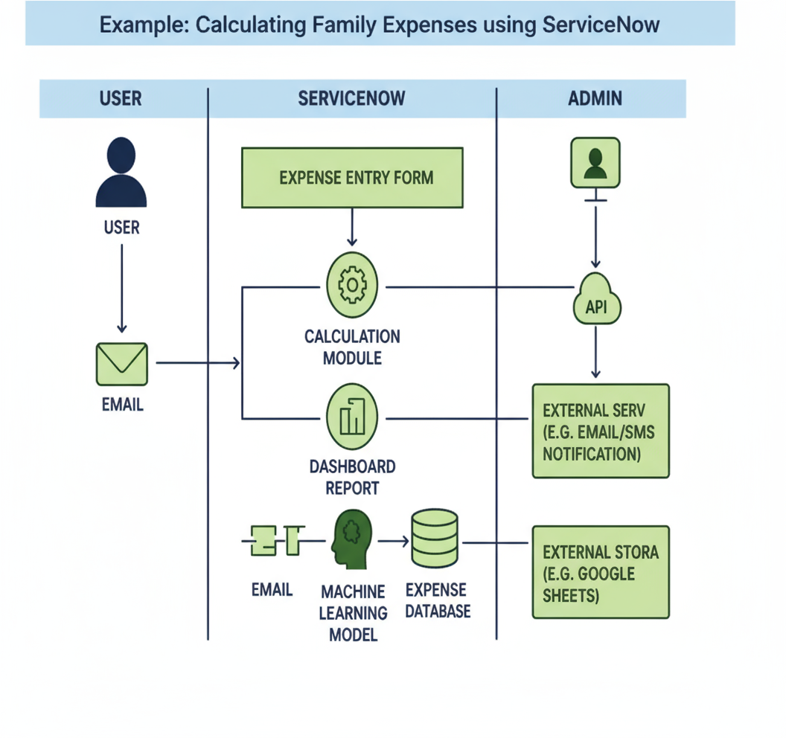

Table-1 : Components & Technologies:

S.No | Component | Description | Technology
1. | User Interface | Family members interact via Web dashboard to track expenses and manage budgets in ServiceNow. | ServiceNow Web UI
2. | Application Logic-1 | Categorizes expenses into predefined categories (food, utilities, entertainment, etc.) | ServiceNow Flow Designer, Script
3. | Application Logic-2 | Validates expenses against set budget limits and alerts when thresholds are exceeded | GlideRecord in Server Script
4. | Application Logic-3 | Generates expense reports and sends notifications for budget alerts and spending summaries | ServiceNow Notifications
5. | Database | Stores family expense records, budget data, and category information | ServiceNow CMDB, Expense Tables
6. | Cloud Database | Managed by ServiceNow cloud backend. | ServiceNow Cloud Database
7. | File Storage | Minimal use; logs stored internally | ServiceNow system logs
8. | External API-1 | (Optional) Integration with banking APIs for automatic expense import | REST API in ServiceNow
9. | External API-2 | Not applicable | ₋
10. | Machine Learning Model | Not applicable for current use case | ₋
11. | Infrastructure (Server / Cloud) | Hosted and managed on ServiceNow SaaS platform | ServiceNow Cloud (SaaS)

Table-2: Application Characteristics:

S.No | Characteristics | Description | Technology
1. | Open-Source Frameworks | Not applicable (ServiceNow is proprietary) | ₋
2. | Security Implementations | Family member authentication, role-based access, data privacy controls | ACLs, Scoped Applications
3. | Scalable Architecture | Scalable to support multiple families and growing expense data on ServiceNow platform | ServiceNow Cloud Architecture
4. | Availability | 24/7 access for family members with ServiceNow cloud reliability | Load-balanced ServiceNow Instances
5. | Performance | Fast expense entry and real-time budget tracking with optimized ServiceNow workflows | GlideRecord, Background Scripts

